

STAREHE GIRLS’ 2025 PREDICTION
POSSIBLE KCSE EXAM
231/3
BIOLOGY
PAPER 3 (PRACTICAL)
TIME: 1¾ HOURS

NAME……………………………………………………………………………………….
SCHOOL……………………………………………… SIGN………………………..
INDEX NO……………………………………………. ADM NO……………………

(Kenya Certificate of Secondary Education)

INSTRUCTIONS TO CANDIDATES:
- Write your name and admission number in the spaces provided.
- Sign and write date of examination in the spaces provided above
- Answer all the questions in section in the spaces provided after each question only
- You are required to spend the first 15 minutes of the 1 ¾ hours allowed for this paper, reading the whole paper carefully before starting to do this paper.

For Examiner’s Use Only:
QUESTIONS | MAXIMUM SCORE | CANDIDATE’S SCORE
1 | 14
2 | 14
3 | 12
TOTAL | 40

1. You are provided with olive oil, liquids labeled L₁ and L_{2,} and an Irish potato.
Label two test tubes A and B.
Place 2 cm³ of water in each test tube.
Add 8 drops of olive oil into each test tube.
To test tube labelled A add 8 drops of liquid L₁
Shake both test tubes. Allow to stand for 2 minutes.
(a)i) Record your observations. (2 Marks)
Test tube A.
…………………………………………………………………………………………………………
…………………………………………………………………………………………………………
Test tube B.
…………………………………………………………………………………………………………
…………………………………………………………………………………………………………
(ii) Name the process that has taken place in test tube A. (1 Mark)
…………………………………………………………………………………………………………
(iii) State the significance of the process named in (a)(ii) above. (1 Mark)
…………………………………………………………………………………………………………
…………………………………………………………………………………………………………

(iv) Name the:
Digestive juice in humans that has the same effect on oil as liquid L_{1.} (1 Mark)
…………………………………………………………………………………………………………
Region of alimentary canal into which the juice is secreted. (1 Mark)
…………………………………………………………………………………………………………

(b) Label two test tubes C and D.
Place 2 cm³ of liquid L₂ into each test tube. Add one drop of iodine solution into each test tube.
(i) Record your observation. (1 Mark)
…………………………………………………………………………………………………………
…………………………………………………………………………………………………………

(ii) What is the identity of L_{2?} (1 Mark)
…………………………………………………………………………………………………………

Cut a cube whose sides are 1cm from the Irish potato provided. Crush the cube to obtain a paste. Place the paste in the test tube labeled C. Leave the set up for at least 30 minutes.
(iii) Record your observation in C and D (2 Marks)
C ………………………………………………………………………………………………………
D ……………………………………………………………………………………………………...

(iv) Account for the results in (b)(iii) above. (4 Marks)
C………………………………………………………………………………………………………
…………………………………………………………………………………………………….................
D………………………………………………………………………………………………………
…………………………………………………………………………………………………….................

2. Below are photographs of specimens obtained from plants. Examine the photographs and use them to answer the questions that follow.

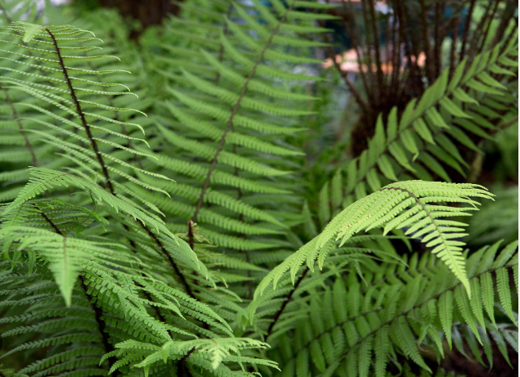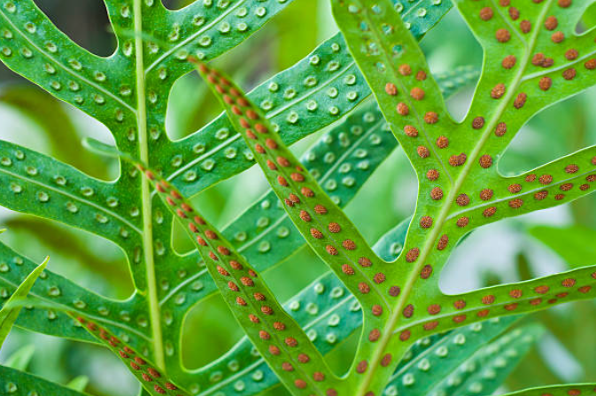
A
P

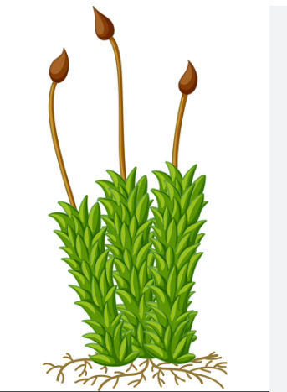
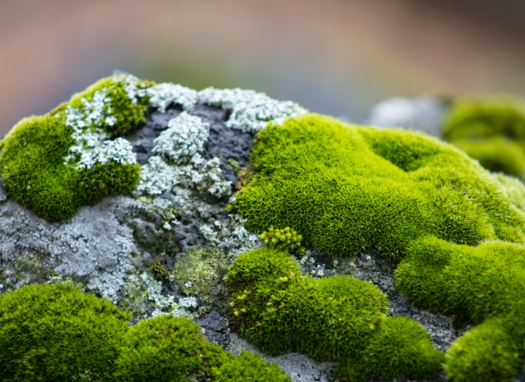
B
Q

(a). Name the plants and state the divisions in which these specimens belong (4 Marks)
A
Name…………………………………………………………………………………………………
Division………………………………………………………………………………………………
B
Name…………………………………………………………………………………………………
Division………………………………………………………………………………………………

(b). On the diagrams, name structure labelled P and Q (2 Marks)
(c). State two similarities and two differences of the organisms represented by the images above.
Similarities (2 Marks)
…………………………………………………………………………………………………………
…………………………………………………………………………………………………………
…………………………………………………………………………………………………………
…………………………………………………………………………………………………………

Differences (2 Marks)
…………………………………………………………………………………………………………
…………………………………………………………………………………………………………
…………………………………………………………………………………………………………
…………………………………………………………………………………………………………

(d). The organisms shown above shows alternation of generation.
(i) Explain what is meant by the concept alternation of generation. (1 Mark)
…………………………………………………………………………………………………………
…………………………………………………………………………………………………………

(ii) Which is the dominant generation in the organisms represented by image A (1 Mark)
…………………………………………………………………………………………………………
…………………………………………………………………………………………………………

(e). Name the two structures that produce gametes when the two-organisms shown above are reproducing by means of gametes. (2 Marks)
…………………………………………………………………………………………………………
…………………………………………………………………………………………………………
…………………………………………………………………………………………………………

3. The images below were obtained from certain system in a mammal. Study the images and use them to answer the questions that follow.
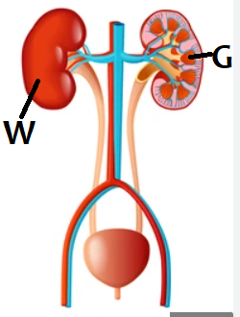

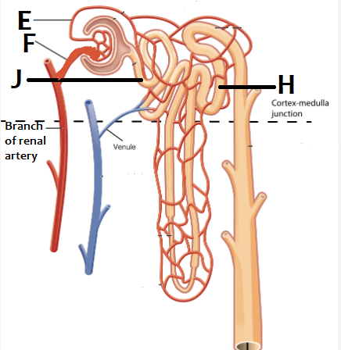
(a) Name the part labeleld W and state its functions.
Name (1 Marks)
…………………………………………………………………………………………………………
Functions (2 Marks)
…………………………………………………………………………………………………………
…………………………………………………………………………………………………………
…………………………………………………………………………………………………………

(b). State one difference between vessel E and F and explain its importance.
Difference (1 Mark)
…………………………………………………………………………………………………………
…………………………………………………………………………………………………………
…………………………………………………………………………………………………………
Importance (1 Mark)
…………………………………………………………………………………………………………
…………………………………………………………………………………………………………

(c). (i) Name two substances reabsorbed in part labelled J (2 Marks)
…………………………………………………………………………………………………………
…………………………………………………………………………………………………………
…………………………………………………………………………………………………………

(ii) Identify the physiological process involved in reabsorption of substances in part H (1 Mark)
…………………………………………………………………………………………………………
…………………………………………………………………………………………………………

(iii) Explain four adaptions of part H and J to its functions (4 Marks)
…………………………………………………………………………………………………………
…………………………………………………………………………………………………………
…………………………………………………………………………………………………………
…………………………………………………………………………………………………………
…………………………………………………………………………………………………………

